**Questions**

Question on Dup2()

Q 2.1 ) dup2(fd, 1);

Question on Pipe()

Q 1.1 pipe(pipe_fds);

Q 1.2 while ((nread = read(pipe_fds[0], buff, buffer_size)) != 0)

Q 1.3 write(pipe_fds[1], inbuff, buffer_size);

Q 1.4 close(pipe_fds[1]);

Q 1.5 wait(NULL);

Capture Output of Lab8b_2.sh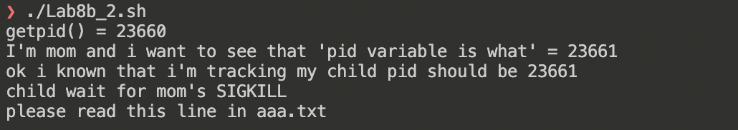

Question on Q1 (factorial max value) (macos)

2 power n :

Recieved a signal SIGUSR1. the max n is 20! = 2432902008176640000

Question on Q2 (write program using SIGKILL)

